

-Vishnu jagadeesh

(Software requirement specification

SRS FOR DIABETES DETECTOR

Test Plan Identifier: Diabetes detector

Introduction:

this test plan is written to the system testing for the Diabetes detection

Test Items:

the following test items will be tested in this plan:

-accuracy of Diabetes detection using blood pressure and glucose level.

Features To Be Tested:

the following features will be tested as a part of system testing:

* Glucose level
* Blood-pressure level

Features Not to Be Tested: Not applicable

Approach:

Our diabetes detection project provides accurate output whether a person is having diabetes or not by considering the blood pressure and glucose level in the blood, this will be done by comparing of the data.

Item Pass/Fail Criteria:

Every test case will have input and processing and expected output. If the output is according to the expected output, it is pass or else it is failed.

Suspension Criteria and Resumption Requirements:

During the system testing if the number of defects is more the test team will suspend the testing activities and after all the defects are fixed by the development team the test team will resume the testing again.

**Product Functionality:**

R1: Download data in CSV format

R2: Using pandas extract features and label from CSV file

R3: Build ML Model using ML Algorithm

R4: Predict using the test cases

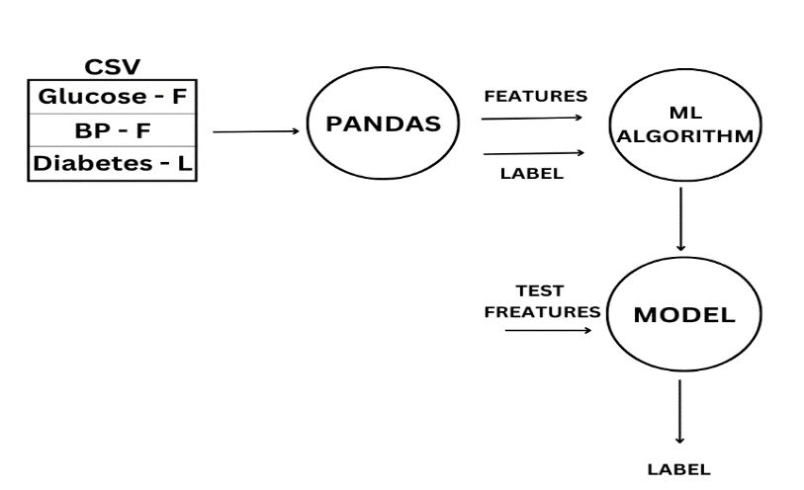

Test Deliverables:

* Test plan
* Test case
* Test script
* Test scripts automation

Testing Tasks:

* Setting up the test system with the product called diabetes detector.
* Execute all the test case + test scripts
* Generate reports and share it with development team.

Environmental Needs:

* Pentium 17 machines with windows 10
* Product software
* Report of people’s medical data
* A team of people who know very well about medical science.

Responsibilities:

The responsibility of the system teste team is to execute all the test scripts and give or generate the report, which contains how many test scripts are passed or failed.

Staffing And Training Needs: three engineers are required

Schedule: one month

Risks And Contingencies: Not applicable

Approvals:

The test plan has to be approved by the:

- project manager

- Developers

- customer